Thank you for your interest in holding a private event at The Mash House.

We have 2 private spaces that can be arranged to accommodate Hail and Farewells, Rehearsal Dinners, Private Birthdays, Intimate Wedding Dinners, Reunions Corporate and Pharmaceutical Functions, and much more!

This package lists some key details about our private rooms and menus available. Seeking a type of menu not listed? Let us know and our from-scratch kitchen can work up a special menu just for your event. Please give us a call or send an email to Marilynn@TheMashHouse.com for more information. We look forward to helping make your event extraordinary!

“Private Patio”
This area holds up to 80 people and it is covered and enclosed. It is heated during colder months and slightly cooled in the summer. This space has a spending minimum to meet based on how long the room is occupied, though it must be reserved for a minimum of 2 hours. All food, beverage, and alcohol purchases go towards this spending minimum. If the spending minimum is reached, there is no additional room fee! This area features flat screen TVs that can be used for presentations or slide shows, a gas fireplace, and it can be arranged multiple ways to suit your needs.

“PDR”
This is our indoor private dining room which holds 30 to 40 people. This room must be reserved for at least 2 hours and has a flat hourly fee. The room features a fun chalk board where a special message can be written and shades that’s can be drawn to make the space feel extra private.

Day Time Events
The Mash House is not typically open during the week for lunch however we will open for private, contracted events with 40 or more guests. Day time events must conclude by 3pm. Day time events can utilize our Patio or our entire Main Dining Room.

Plated Options
For up to 40 guests. All plated options include unlimited pepsi products, iced tea, and coffee

Menu A – Steak and Chicken Mixed Grill

- First Course: Mixed Green Salad with Croutons, Carrots, Cucumbers, and Tomatoes

- Entrée :
Grilled 6oz Sirloin paired with Chicken Breast (both proteins on plate)
Served with Asparagus & Garlic Mashed Potatoes

- Optional dessert:
Mix of mini cheesecakes and butterscotch brownie bites, served family style

Menu B – Steak and Shrimp Mixed Grill

- First Course: Mixed Green Salad with Croutons, Carrots, Cucumbers, and Tomatoes

- Entrée:
Grilled 6oz Sirloin topped with Sautéed or Fried Shrimp.
Served with Asparagus & Garlic Mashed Potatoes
(Host selects if all shrimp will be sautéed or fried)

- Optional dessert:
Mix of mini cheesecakes and butterscotch brownie bites, served family style

Menu C – Traditional Selection

- First Course: Mixed Green Salad or Caesar Salad

- Entrée Selection:
Herb Roasted Chicken, Asparagus & Garlic Mashed Potatoes
Grilled Salmon, Asparagus & Garlic Mashed Potatoes
Beef Option, Asparagus & Garlic Mashed Potatoes
Vegetarian Pasta

(Host selects if beef option will be a 12oz Ribeye or 10oz Herb Crusted Prime Rib)

- Optional dessert:
Mix of mini cheesecakes and butterscotch brownie bites, served family style

Children’s Menus available for Kids 12 and under.

Buffet Options
For 40 or more guests.
All buffets (except for the appetizer buffet) include unlimited pepsi products, iced tea, and coffee.

Buffet D – Build Your Own Burger Bar

- All Items on Buffet:
6oz House ground cheese burger patties
Grilled Chicken Breasts
(Vegetarian and Cheese-less burgers on request)
lettuce, tomato, onion, sweet pickles, mayo, ketchup, mustard
Cole Slaw
Baked Mac and Cheese

- Optional dessert:
Mix of mini cheesecakes and butterscotch brownie bites, served family style

Buffet E – Mash House BBQ

- All Items on Buffet:
Sweet Rolls
Pulled Pork with house-made BBQ Sauce
Herb Grilled Chicken Breast
Chef’s Choice Pasta
Cole Slaw
Garlic Mashed Potatoes
Chef’s Choice Vegetables

- Optional dessert:
Mix of mini cheesecakes and butterscotch brownie bites, served family style

Buffet F – Traditional Buffet

- All Items on Buffet:
Mixed Green Salad
Herb Roasted Chicken
Meatloaf
Baked Lemon Pepper White Fish
Garlic Mashed Potatoes
Chef’s Choice Vegetables

- Optional dessert:
Mix of mini cheesecakes and butterscotch brownie bites, served family style

Buffet G – Prime Rib Carving Station

- All Items on Buffet:
Mixed Green Salad
Herb Roasted Chicken
Shrimp & Grits
Slow-roasted, Herb-crusted Prime Rib (hand-cut by a chef on buffet line)
Au Jus Sauce
Garlic Mashed Potatoes
Chef’s Choice Vegetables

- Optional dessert:
Mix of mini cheesecakes and butterscotch brownie bites, served family style

Buffet H – Appetizer Buffet
not to be expected as a full meal, more for a light social event

- All Items on Buffet:
Buffalo Wings marinated in our Copper Head Red Ale
Pulled BBQ Pork Loaded Potato Skins
Bruschetta with Parmesan Herb Flat Bread
Corn Tortilla Chips
Artichoke and Spinach Dip
House-made Beer Queso

- Optional dessert:
Mix of mini cheesecakes and butterscotch brownie bites, served family style

Children’s Menus available for Kids 12 and under.

Appetizer List

Select 2 types of appetizers to be served before your dinner for an additional price.

House Made Beer Queso
Served with house made tortilla chips

Bruschetta
A classic mix of tomatoes, basil, roasted garlic and balsamic reduction served with Parmesan herb flatbread

Artichoke and Spinach Dip
Served with Tortilla Chips

Mash House Wings
Marinated in our Copper Head Red Ale and tossed in your choice of:
House Made Buffalo Sauce
or
Asian BBQ Sauce

Mash House Loaded Potato Skins
Deep fried and stuffed with your choice of:

Pulled BBQ pork, pepper jack cheese, chives and sour cream
or
Chicken verde, cheddar cheese, sliced jalapeno’s and our house aioli

Patio
Covered, Enclosed, Heated, Sliding Open Panels, Fire Place, Flat Screen TVs.
Room can be configured many ways.
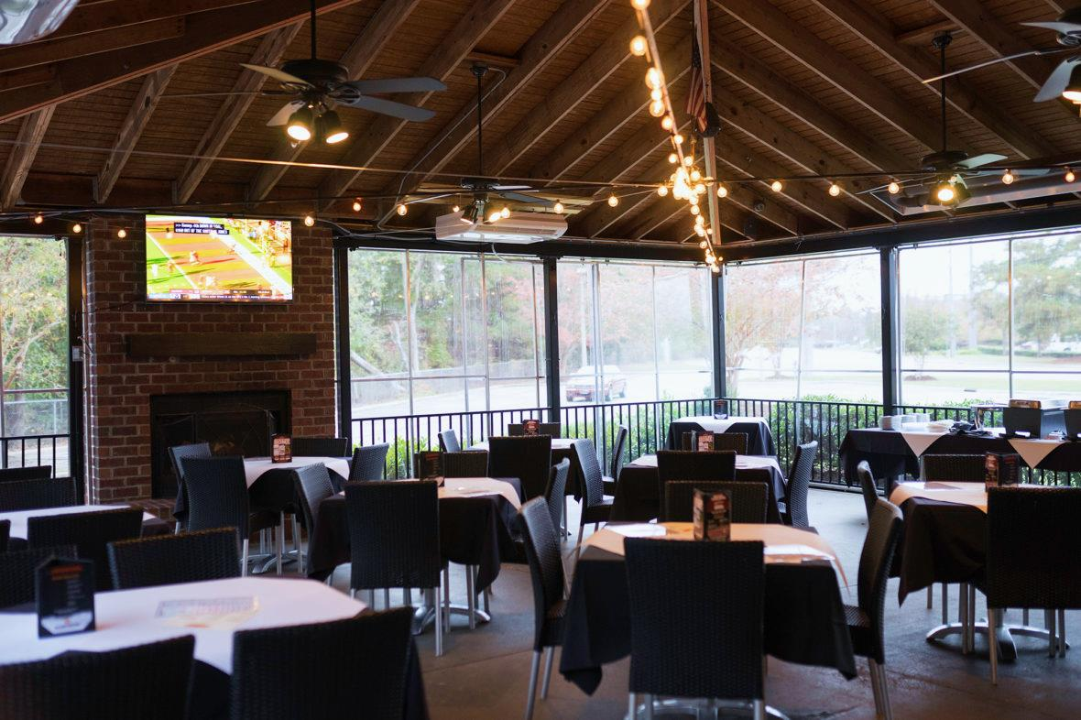
Holds a maximum of 60-80.
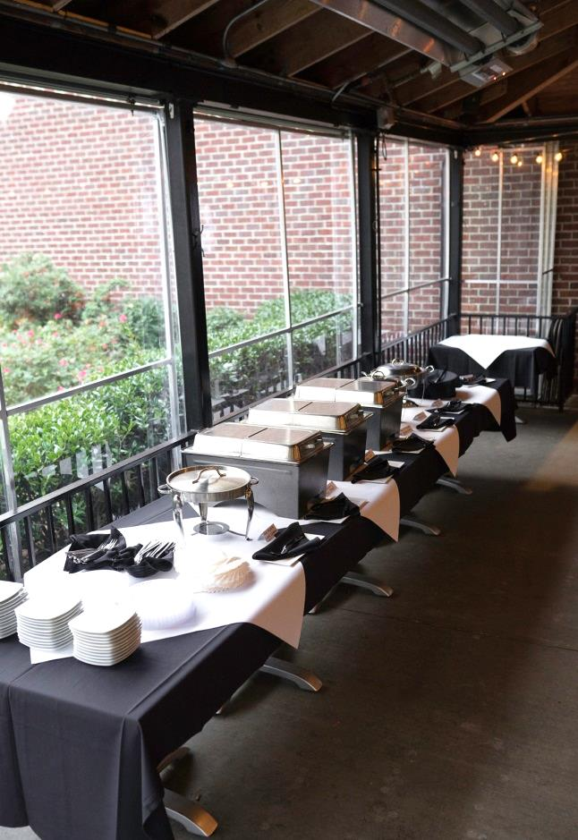

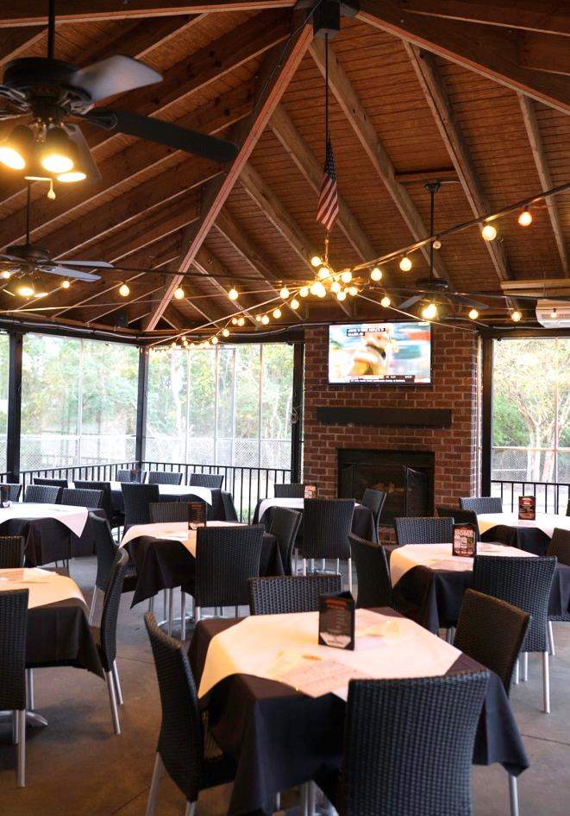

Patio Continued
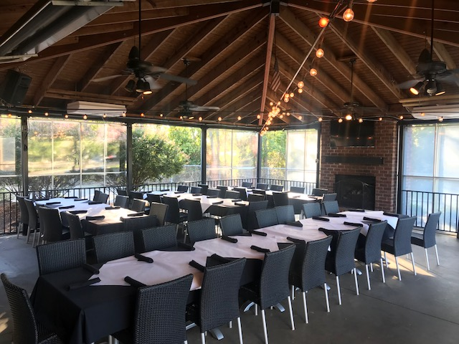
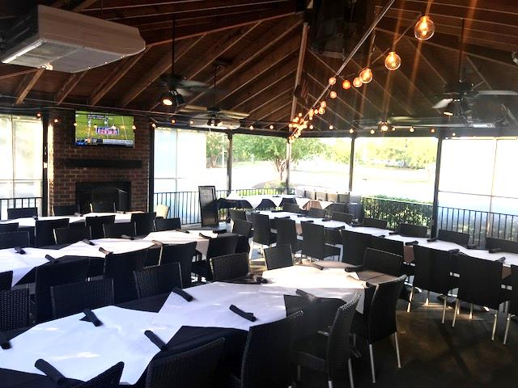

“PDR”
Indoor Dining Room, Glass Windows to dining room can be covered with shades. Chalk board massage board on wall.
Holds a maximum of 40 people.
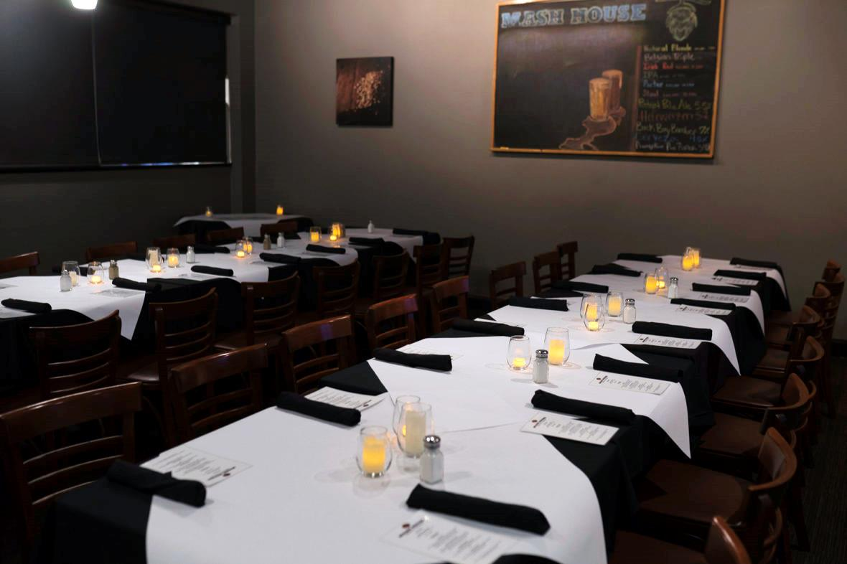
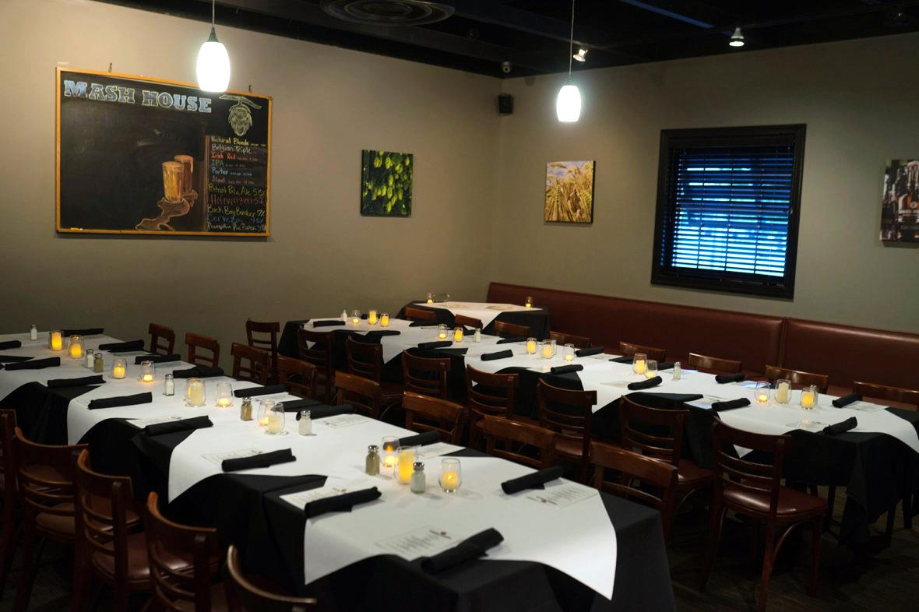

“PDR” Continued
